MongoDB CRUD operations

* Create a database called "contact"
* Create a collection called "contactlist"

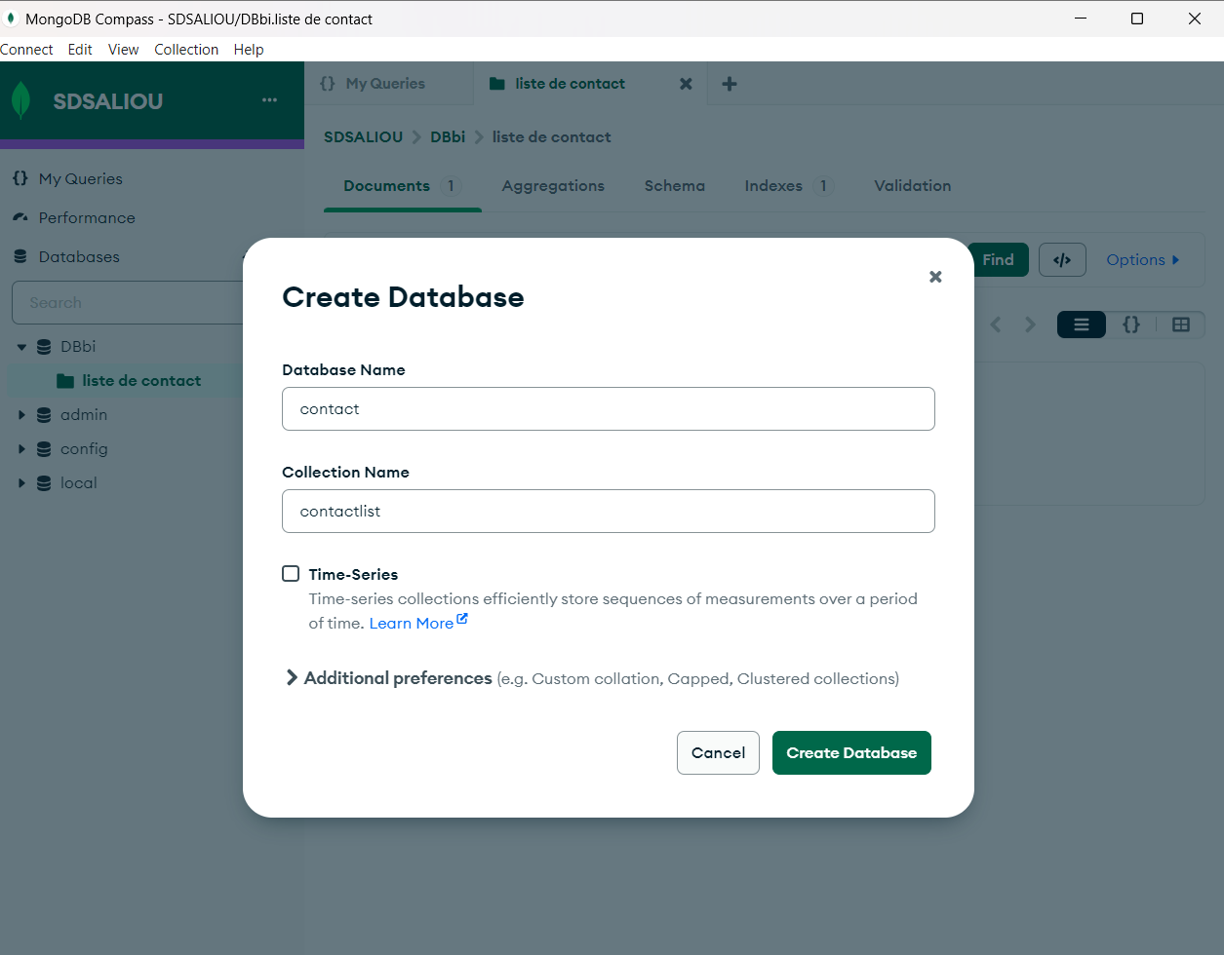

* Insert these documents  in "contactlist" :

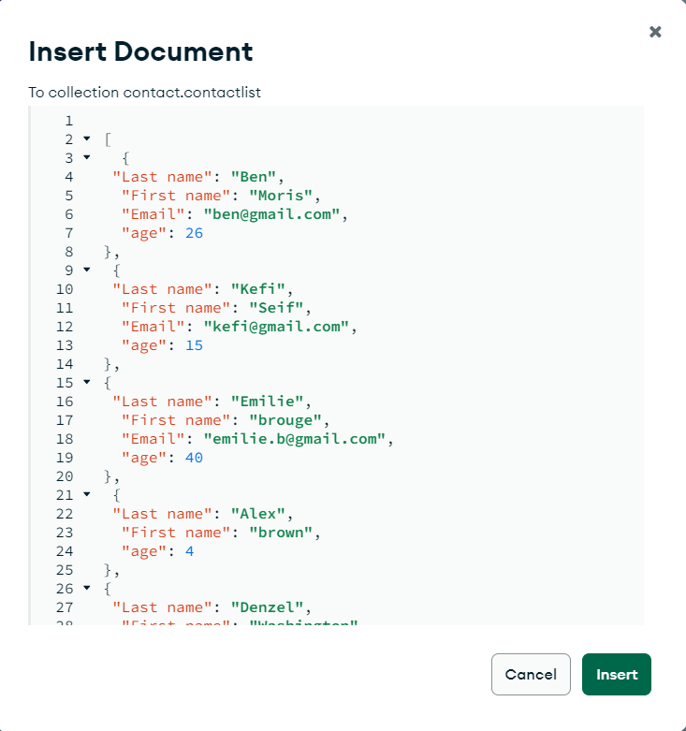

* + Last name: Ben, First name: Moris, Email: ben@gmail.com, age:26
  + Last name: Kefi, First name: Seif, Email: kefi@gmail.com, age:15
  + Last name: Emilie, First name: brouge, Email: emilie.b@gmail.com, age:40
  + Last name: Alex, First name: brown, age: 4
  + Last name: Denzel, First name: Washington, age:3

**Instructions**

* Display all of the contacts list.
  + Display all the information about only one person using his ID.

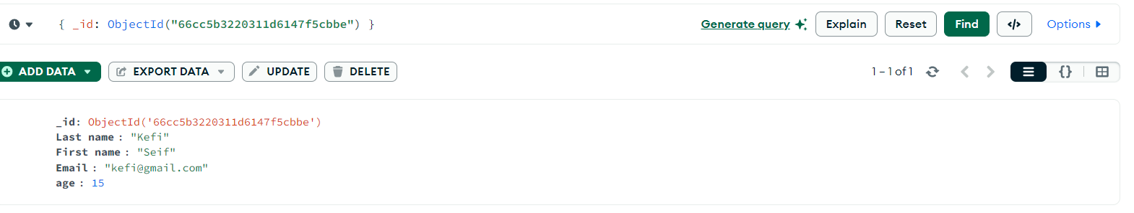

* + Display all the contacts with an age >18.

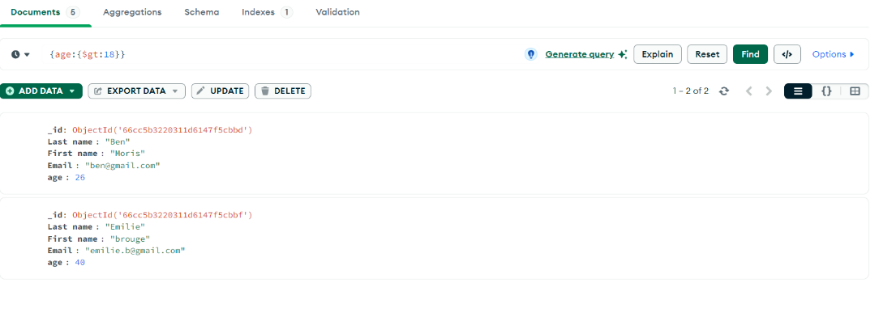

* + Display all the contacts with an age>18 and name containing "ah".

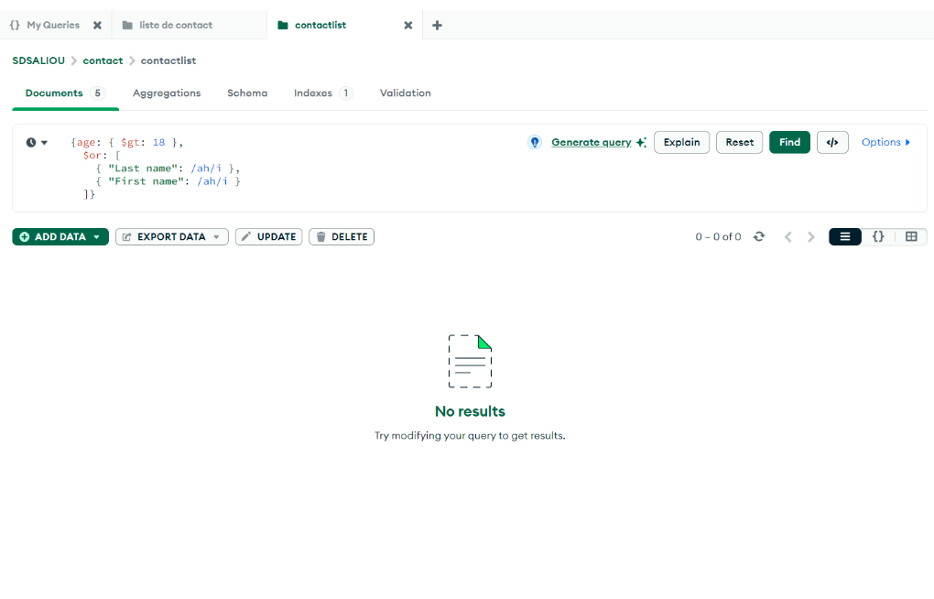

* + Change the contact's first name from"Kefi Seif" to "Kefi Anis".

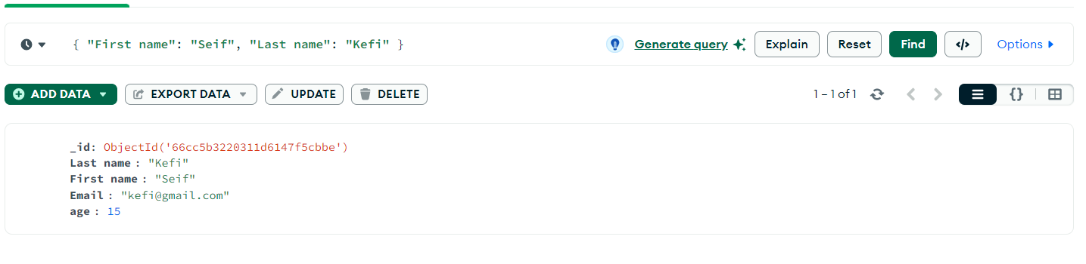

Je sélectionne puis je clique sur update

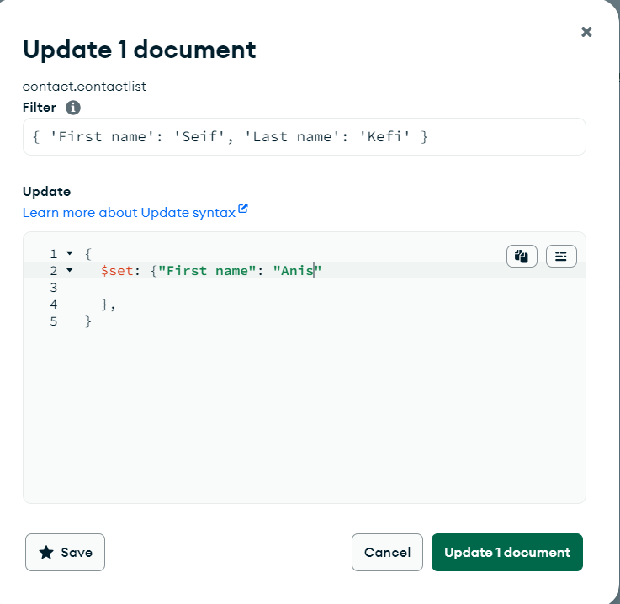

* + Delete the contacts that are aged under <5.

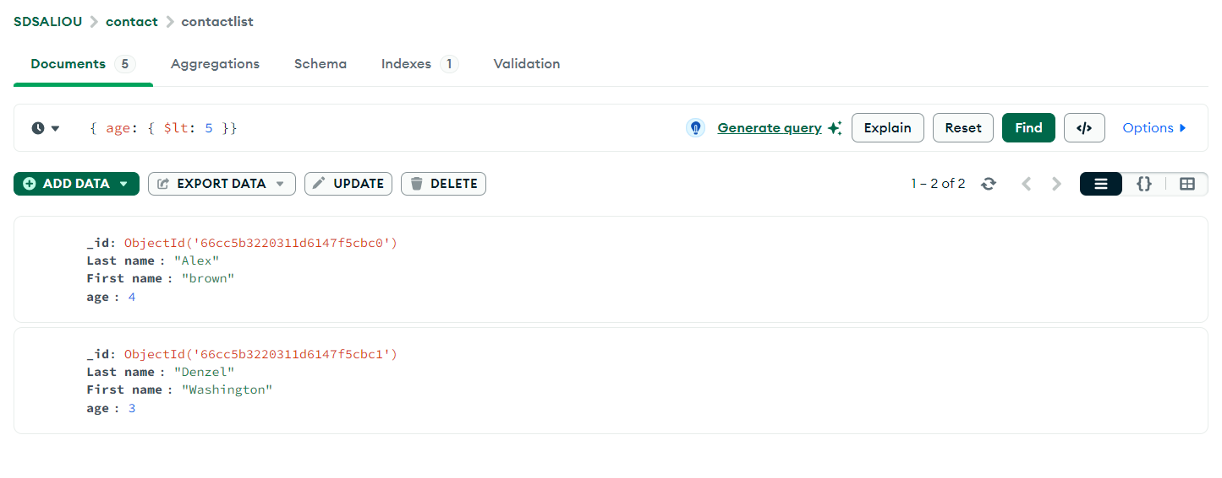

Je sélectionne puis je clique sur Delete

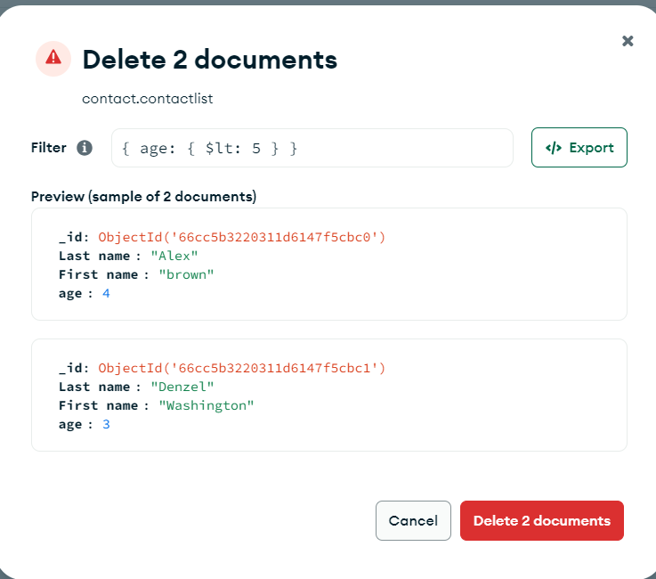

* + Display all of the contacts list.

